PRIME FACTORIAL GENERATOR

Table of Contents

INTRODUCTION 2

SPECIFICATIONS 2

SOFTWARES REQUIRED 3

SOURCE CODE 3

INSTALLATION NOTES 3

ABOUT THE APPLICATION 3

TEST CASES 4

# INTRODUCTION

The Prime Factorial Generator takes a positive number as input and generates its Prime Factors.

Assumption: Prime Factors not possible for negative numbers. Refer to answer one of <https://primes.utm.edu/notes/faq/negative_primes.html>.

# SPECIFICATIONS

When a page loads, the following information should be provided:

* A Clock displaying the current time in 24 hr format
* A timer spinner that cycles every 125ms
* An Input field
* A GENERATE button which when clicked generates all the prime factors for the given input.
* A Results Area
* A CLEAR Button but is hidden until Results area is populated with Factors
* A RESET Button but is hidden until the Input abides by the constraints mentioned below.
* A RESET button which when clicked clears all the generated prime factors for the given input. The button should also reset the Input field and clear the Error messages if any.
* An Error area which is displayed whenever the user provides inputs which do not follow the constraints

When the User provides an input, it should comply with the following constraints:

* The number should be positive and greater than Zero (0).

When the user provides a valid input and clicks on the GENERATE Button:

### Default message must be displayed until the factors are calculated

### The generated Factors must be populated replacing the default message in the Results area

### CLEAR button must be displayed

When the user provides invalid input:

* Error message must be displayed
* GENERATE Button must be de-activated
* RESET button must be activated

# SOFTWARES REQUIRED

The software that are needed for the application to be edited or executed

### ‘*browser’* 🡪 Any latest browser like Chrome, Firefox or Safari.

# SOURCE CODE

The Source code for the application is in the ‘*PrimeFactorialGenerator*’ folder

### ‘*index.html*’ 🡪 This file has the javascript and jQuery source code for the application.

### ‘styles.css’ 🡪 This file has the styling for the page.

# INSTALLATION NOTES

Simply double click on the 'index.html' file or Right-click on the 'index.html' file and open it in any browser of your choice

# ABOUT THE APPLICATION

This application loads and allows the user to feed a positive number as Input and generate its Prime Factors. The application begins at the page displayed in screen shown in Figure 1.

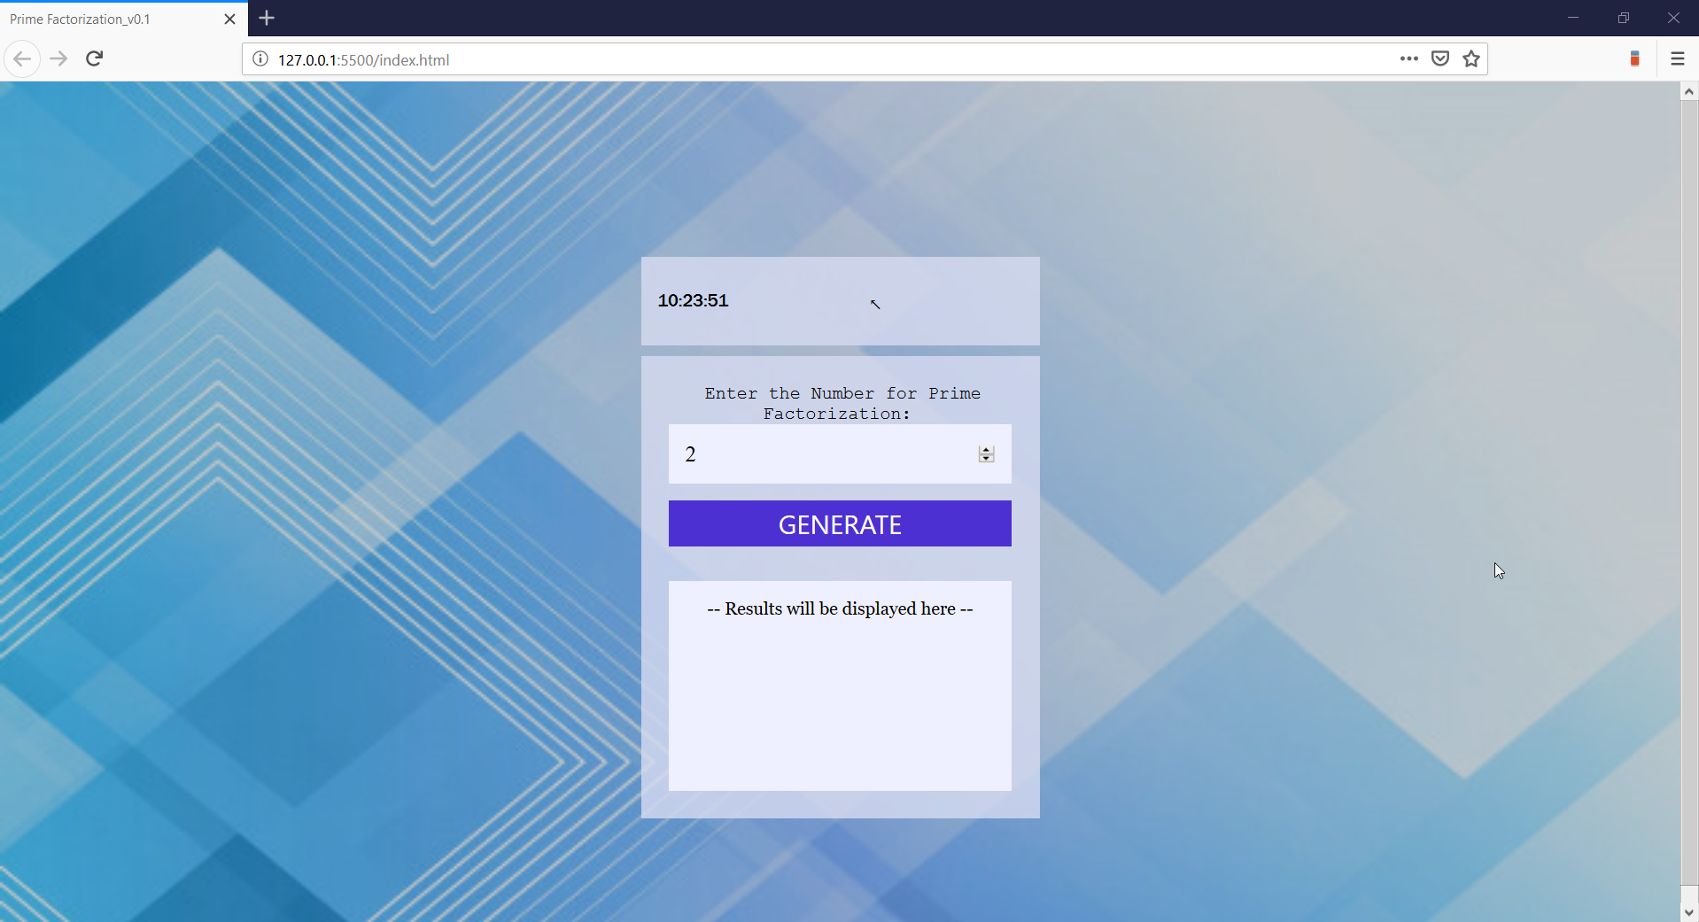

Figure 1: Load-up screen and also Reset screen

If the user provides an in-valid input then the screen show in Figure 2 is displayed.

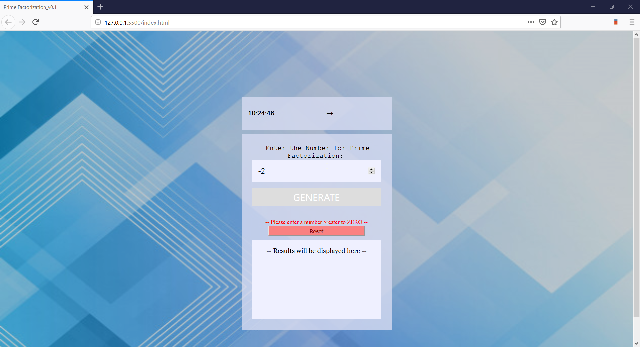

Figure 2: Screen with Error message for in-appropriate Inputs.

# TEST CASES

If the user provides an valid input but there are no prime factors for it then the screen show in Figure 3 is displayed.

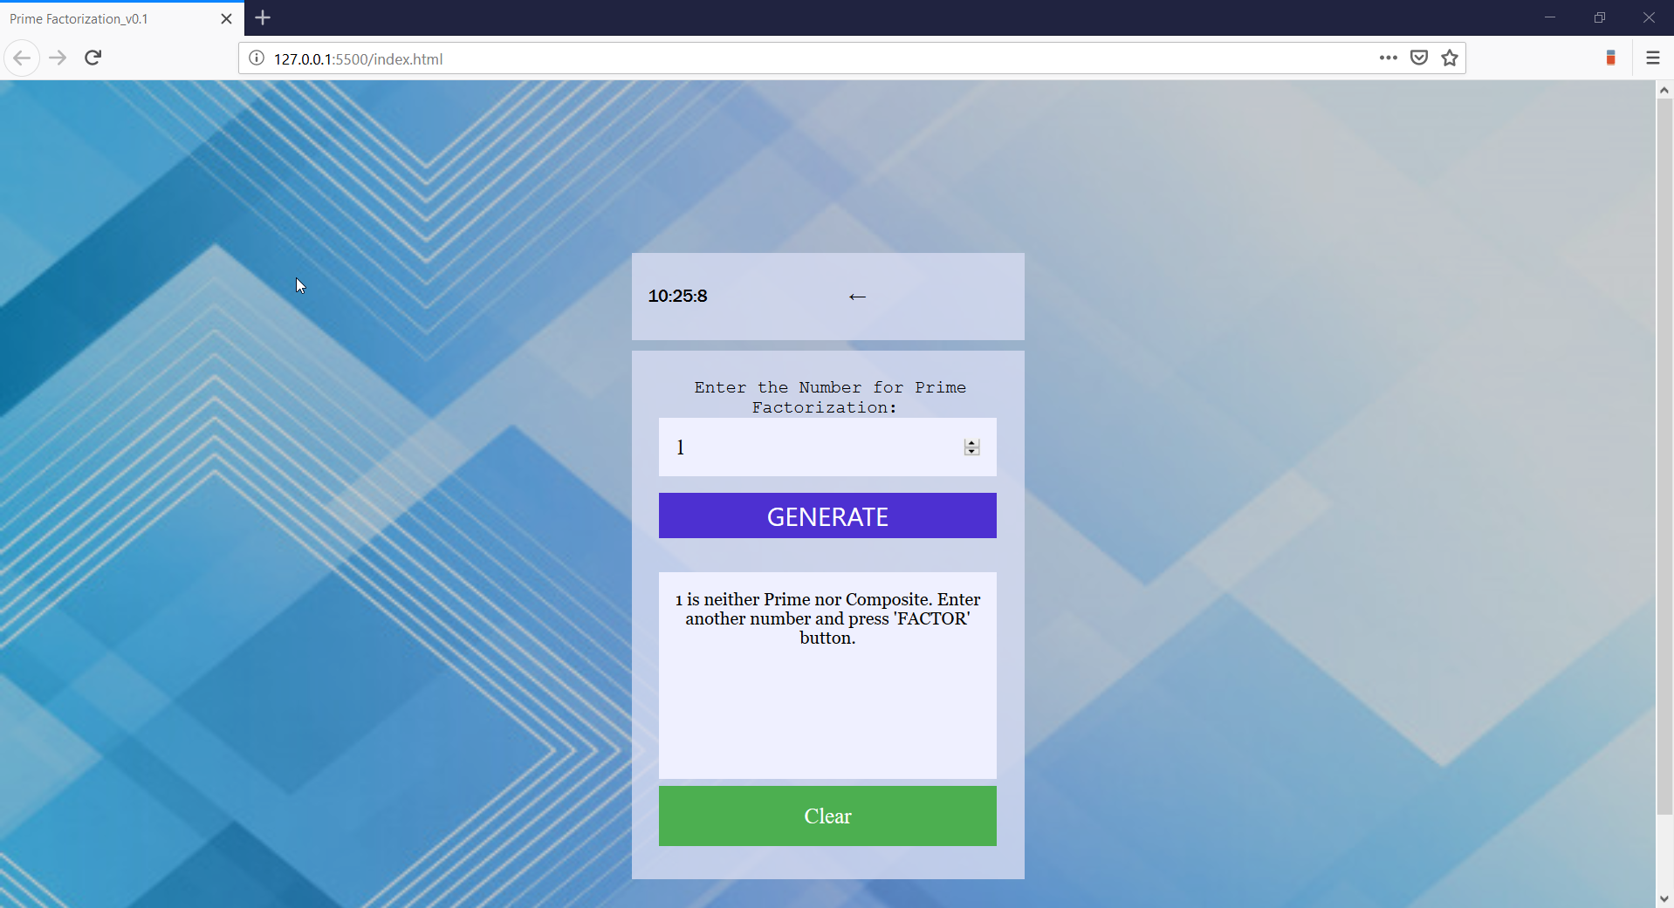

Figure 3: Screen when the numeric One is attempted to be factored

If the user provides an no input then the screen show in Figure 4 is displayed.

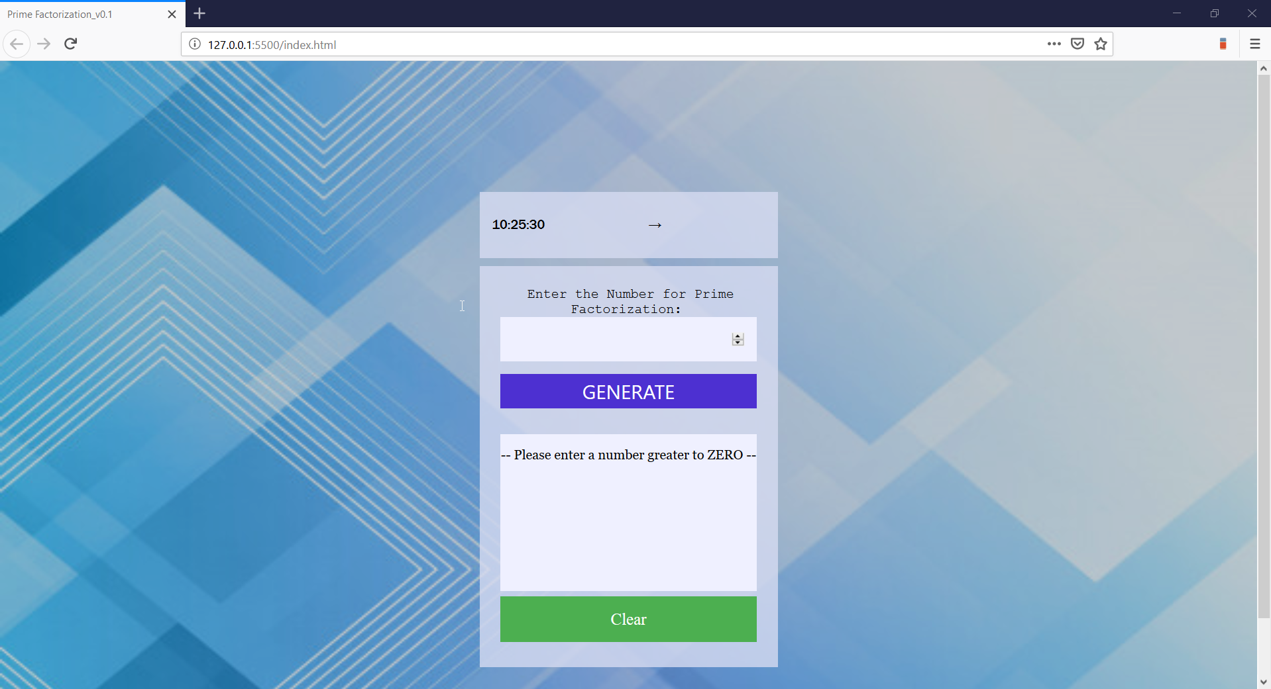

Figure 4: Screen when blank input is attempted to be factored

If the user provides a valid input then the screen show in Figure 5 is displayed.

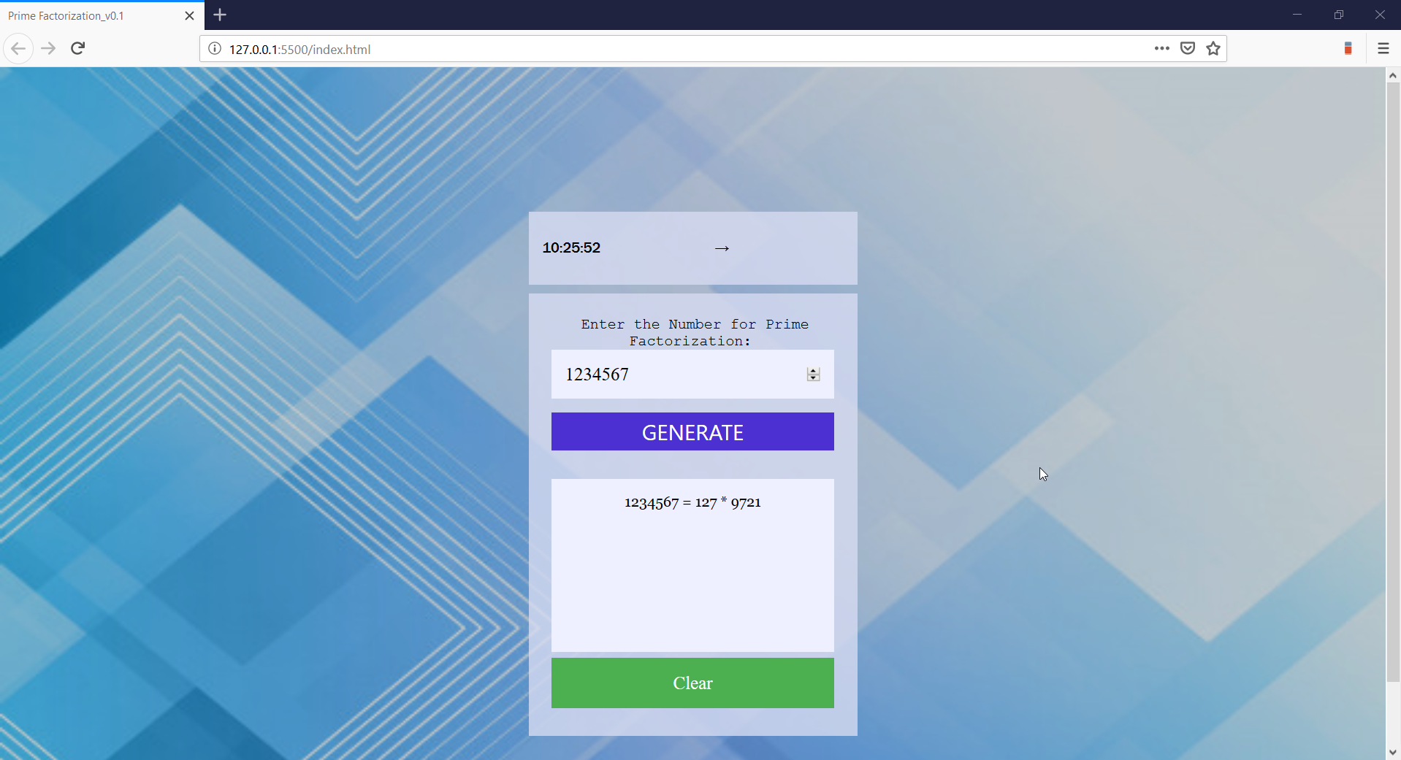

Figure 5: Screen for normal number prime factorization

If the user provides a valid large input then the screen show in Figure 6 is displayed.

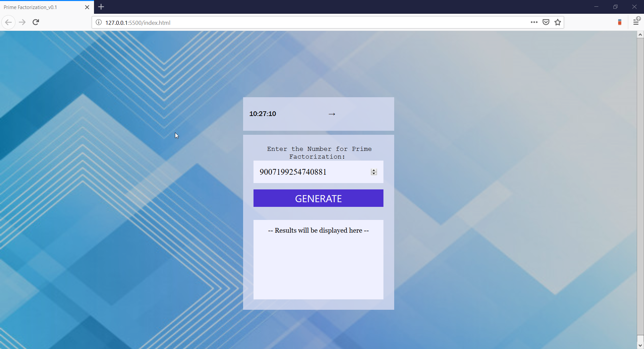

Figure 6: Screen for large number prime factorization